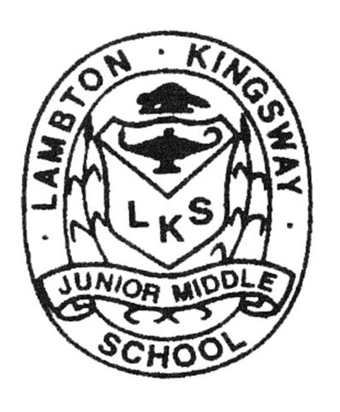

Student Expectations

As a student at Lambton-Kingsway Junior Middle School:
- I follow all the TDSB, school and class rules and routines.
- I do my best and I am polite and courteous to others at all times.
- I always keep my hands, feet and other objects to myself.
- I arrive on time and prepared for class. If I am going to be late/absent, I will have a parent/ guardian call the school. If I am late, I will get a late slip.
- I will not bring electronic devices (cell phones, music players) into the classroom. I will leave these things at home unless absolutely necessary. If they must come to school, they will remain in my locker during school hours. I am fully responsible if these objects are lost or stolen.

Dress Code:
- I will dress in an appropriate manner at all times
- I will not wear attire that has language and/or representations that depict violence, profanity, racial or gender discrimination, or could be seen as offensive by any individual or group.
- I will not wear a hat/cap in school. Head gear worn for religious reasons is respected and accepted.
- I will dress appropriately for the weather and have a change of footwear for winter use.
- I will have appropriate clothing for gym class, or I will not be permitted to participate.

Movement through the school (including halls and stairways):
- I will move in a quiet and orderly manner. I will not run!
- I will keep to the right of the hall and stairway at all times.
- I will stay with the flow of my class and I will keep up with the teacher.
- I will enter the gym/ lab/ classroom only with direct permission from a teacher and only when a teacher is present.
- I will try to limit bathroom and water breaks to recess and lunch. If I must go during class time, I will go quickly and quietly and return immediately to class.
- I will never go anywhere in the school on my own. I will always take a buddy with me.
- I will leave the school immediately when dismissed at recess, lunch, and at the end of the day.
- I will not enter the school during recess, lunch or non-school hours without expressed permission.

Locks and Lockers:
- If I have a locker, I must use a lock or clip. I will keep my locker closed at all times. I will give my locker combination to my teacher and no one else.
- I am fully responsible for the condition of my locker and its contents.

